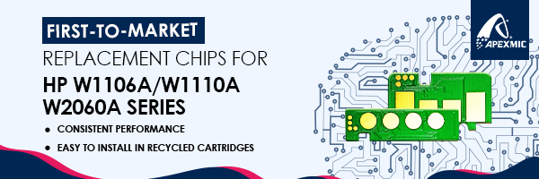

APEX Code | OEM Code | Color | Yield | Region | For Use in Printers
ALH-W1003AC | W1003AC/103A | BK | 1.5K | CHN | HP Laser 103a  HP Laser MFP 131a/133np  New
ALH-W1004AC | W1004AC/104A | BK | 1.5K | IND | HP Laser 103a  HP Laser MFP 131a/133np  Coming Soon!
ALH-W1105A | W1105A/105A | BK | 1K | MX&LA | HP Laser 107a/107w  HP Laser MFP 135a/135w/137fnw  New
ALH-W1106A | W1106A/106A | BK | 1K | EMEA
ALH-W1107A | W1107A/107A | BK | 1K | AP  (ex.CHN/IND)
ALH-W1110A | W1110A/110A | BK | 1.5K | CHN | HP Laser 108a/108w  HP Laser 138pn/138pnw/138p  HP Laser MFP 136w/136a/136nw  New
ALH-W1112A | W1112A/110A | BK | 1.5K | IND
ALH-W1330A | 330A/W1330A | BK | 5K | AMS | HP Laser 408dn  HP Laser MFP 432fdn  Coming Soon!
ALH-W1330X | 330X/W1330X | BK | 15K
ALH-W1331A | 331A/W1331A | BK | 5K | EMEA | HP Laser 408dn  HP Laser MFP 432fdn  New
ALH-W1331X | 331X/W1331X | BK | 15K
ALH-W1332A | 332A/W1332A | BK(Drum) | 30K | WW
ALH-W2060A | W2060A/116A | BK | 1K | AMS | HP Color Laser 150a/150w/150nw  HP Color Laser MFP 178nw/179fnw  New
ALH-W2061A | W2061A/116A | C | 0.7K
ALH-W2062A | W2062A/116A | Y | 0.7K
ALH-W2063A | W2063A/116A | M | 0.7K
ALH-W2070A | W2070A/117A | BK | 1K | EMEA
ALH-W2071A | W2071A/117A | C | 0.7K
ALH-W2072A | W2072A/117A | Y | 0.7K
ALH-W2073A | W2073A /117A | M | 0.7K
ALH-W2080A | W2080A/118A | BK | 1K | CHN
ALH-W2081A | W2081A/118A | C | 0.7K
ALH-W2082A | W2082A/118A | Y | 0.7K
ALH-W2083A | W2083A/118A | M | 0.7K
ALH-W2090A | W2090A/119A | BK | 1K | APJ  (ex.CHN)
ALH-W2091A | W2091A/119A | C | 0.7K
ALH-W2092A | W2092A/119A | Y | 0.7K
ALH-W2093A | W2093A/119A | M | 0.7K
ALH-W1333A | 133A/W1333A | BK | 7.4K | CHN | HP LaserJet MFP M437n/  437dn/437nda/439n/  439dn/439nda  New
ALH-W1333X | 133X/W1333X | BK | 13.7K
ALH-W1334A | 334A/W1334A | BK | 7.4K |  | HP LaserJet MFP M42525n/  42525dn/M42523n/42523d  New
ALH-W1334X | 334X/W1334X | BK | 13.7K
ALH-W1335A | 335A/W1335A | BK | 7.4K | IND/EMEA/  AP(ex.CHN)) | HP LaserJet MFP 438n/M442dn/  M443nda/M440dn/M440n/M440nda  New
ALH-W1335X | 335X/W1335X | BK | 13.7K

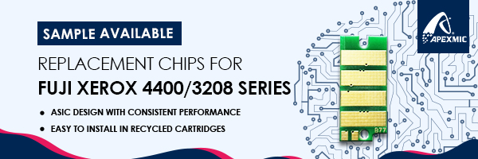

APEX Code | OEM Code | Color | Yield | Region | For Use in Printers
ALX-3090 | CT203090 | BK | 6K | JP | Fujixerox DocuPrint 3200d/4400d/3500d
ALX-3091 | CT203091 | BK | 10K
ALX-3092 | CT203092 | BK | 15K |  | Fujixerox DocuPrint 4400d/3500d
ALNEC-8711 | PR-L8700-11(CT203099) | BK | 6K |  | NEC MultiWriter 8600/8700/8800
ALNEC-8612 | PR-L8600-12(CT203100) | BK | 10K
ALNEC-8712 | PR-L8700-12(CT203101) | BK | 15K |  | NEC MultiWriter 8700/8800
ALX-3094 | CT203094 | BK | 10K | AP(ex.JPN) | Fujixerox DocuPrint 4405d/3505d/3205d
ALX-3095 | CT203095 | BK | 15K
ALX-3096 | CT203096 | BK | 10K
ALX-3097 | CT203097 | BK | 15K
ALF-LB322B | LB322B | BK | 15K | JP | FUJITSU XL-9450
ALX-3211 | CT203211 | BK | 6K |  | FujiXerox DocuPrint C2550d  New
ALX-3212 | CT203212 | C | 6K
ALX-3213 | CT203213 | M | 6K
ALX-3214 | CT203214 | Y | 6K
ALX-3215 | CT203215 | BK | 10K
ALX-3216 | CT203216 | C | 10K
ALX-3217 | CT203217 | M | 10K
ALX-3218 | CT203218 | Y | 10K
ALX-3203 | CT203203 | BK | 7K |  | FujiXerox DocuPrint C3550d  New
ALX-3204 | CT203204 | C | 6K
ALX-3205 | CT203205 | M | 6K
ALX-3206 | CT203206 | Y | 6K
ALX-3207 | CT203207 | BK | 15K
ALX-3208 | CT203208 | C | 10K
ALX-3209 | CT203209 | M | 10K
ALX-3210 | CT203210 | Y | 10K
ALNEC-9114 | PR-L9160C-14 | BK | 6K | JP | NEC MultiWriter 9160C  New
ALNEC-9113 | PR-L9160C-13 | C | 5K
ALNEC-9112 | PR-L9160C-12 | M | 5K
ALNEC-9111 | PR-L9160C-11 | Y | 5K
ALNEC-9119 | PR-L9160C-19 | BK | 10K
ALNEC-9118 | PR-L9160C-18 | C | 9K
ALNEC-9117 | PR-L9160C-17 | M | 9K
ALNEC-9116 | PR-L9160C-16 | Y | 9K
ALNEC-9514 | PR-L9560C-14 | BK | 7K |  | NEC MultiWriter 9560C  New
ALNEC-9513 | PR-L9560C-13 | C | 6K
ALNEC-9512 | PR-L9560C-12 | M | 6K
ALNEC-9511 | PR-L9560C-11 | Y | 6K
ALNEC-9519 | PR-L9560C-19 | BK | 15K
ALNEC-9518 | PR-L9560C-18 | C | 10K
ALNEC-9517 | PR-L9560C-17 | M | 10K
ALNEC-9516 | PR-L9560C-16 | Y | 10K
ALNEC-7211 | PR-L7200-11 | BK | 6K |  | NEC MultiWriter 7200  New
ALNEC-7212 | PR-L7200-12 | BK | 15K
ALNEC-7714 | PR-L7700C-14 | BK | 6K |  | NEC MultiWriter 7700  New
ALNEC-7713 | PR-L7700C-13 | C | 6K
ALNEC-7712 | PR-L7700C-12 | M | 6K
ALNEC-7711 | PR-L7700C-11 | Y | 6K
ALNEC-7719 | PR-L7700C-19 | BK | 11K
ALNEC-7718 | PR-L7700C-18 | C | 11K
ALNEC-7717 | PR-L7700C-17 | M | 11K
ALNEC-7716 | PR-L7700C-16 | Y | 11K

